**Approach**:

1. Create a dummy node to be attached just before start of linkedlist(incase we need to reverse from head itself)
2. Traverse 1 position before the given left index. suppose

1 2 3 4 5 here left is position 2 so NODE 2

Store this reference in pre(here NODE 1)

1. Let prev = pre.next (left indexed node) and cur = prev.next (1 node after the left indexed node)
2. Write code to traverse the linked list starting from cur. (n-m) times
3. Now connecting the nodes at the beginning and end of the linked list

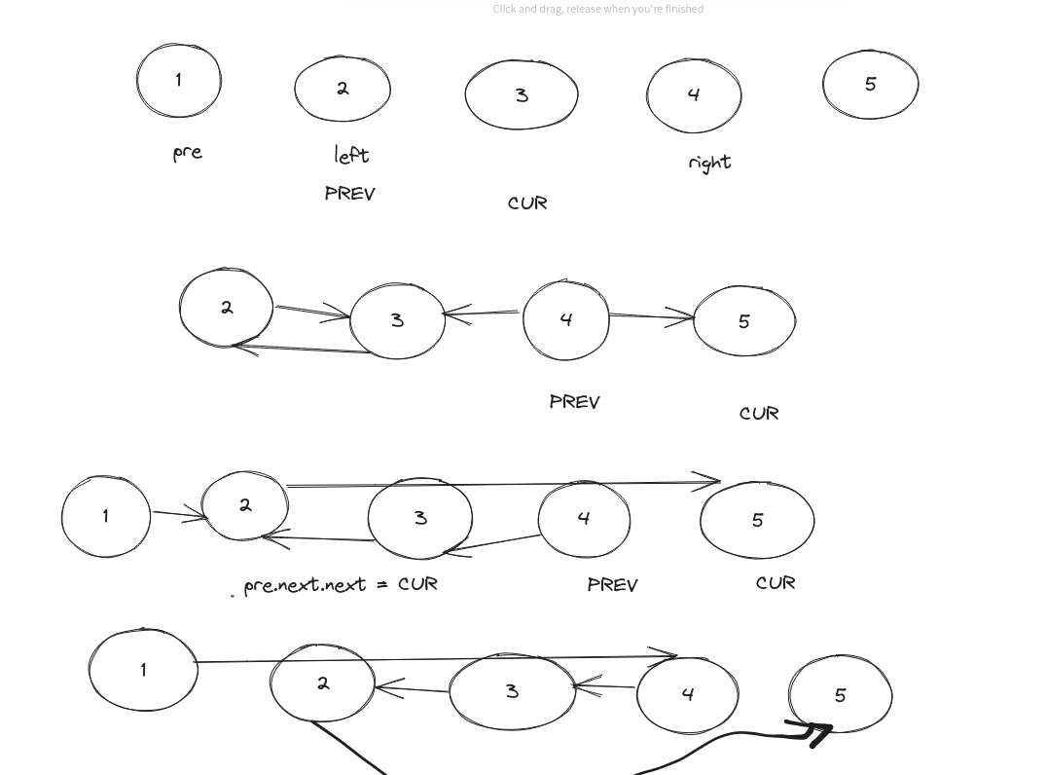

Basically 3 steps

1. Traverse till left indexed node
2. Perform reversal between left indexed and right indexed node
3. Do connections of beginning and end nodes

CODE:

if right == left:

return head

# create a prefix node

dummy = ListNode(0)

dummy.next = head

# store a reference to prefix node

pre = dummy

for i in range(left-1):

pre = pre.next

# reversal

prev = pre.next

cur = prev.next

for i in range(right-left):

temp = cur.next

cur.next = prev

prev = cur

cur = temp

pre.next.next = cur

pre.next = prev

return dummy.next